Manoj S. Kommagiri

SUMMARY
- An expert data and Web development professional with an impeccable record of developing and delivering data driven applications and business intelligence analytics is currently seeking a new role that will draw upon expertise in business intelligence, Reporting, Full stack Web Development, Data analysis, ETL (SSIS) processes and data modeling.

HIGHLIGHTS OF QUALIFICATIONS
- Dedicated IT professional with years of expertise in business analysis, database development, and reporting, primarily across the MS SQL server suite of products for business and financial decision-making.
- Demonstrated success in all aspects of enterprise-wide analytics architecture including data integration, data modeling, and data management, combined with skills in SQL server ETL/reporting tools like SSRS and SSIS.
- Proficient in developing Full Stack Applications and API’s and Reporting Solutions to democratize the data across the organization.
- Utilize Solid design principles and cutting-edge technologies, providing guidance on technology choices per project, taking ownership and working across the full stack.
- Experienced in developing data integration, workflow, and ETL solutions for data warehousing using SSIS.
- Proficient in data structures and fact tables from a variety of systems, including proprietary SQL data tables.
- Competent in dimensional and relational modeling techniques, facilitating informed business decisions.
- Strong quantitative, analytical, critical thinking, and problem-solving skills with exceptional attention to detail.

CORE COMPETENCIES
- Full Stack Web Development | - Business Intelligence & Analytics | - Data Mining & ETL
- Data Integration & Modeling | - System Development Life Cycle | - Enterprise Data Reporting
- Database Development | - IT Application Support | - Documentation & Training

TECHNICAL SKILLS
Databases | SQL Server, Oracle, Sybase, Azure SQL Database
Reporting Tools | SQL Server Reporting Services, Power BI, Tableau, Crystal Reports, (9 / 8 / 10.x)
OLAP Tools | SQL Server Analysis Services 2000 / 2005 / 2008
ETL Tools | SQL Server Integration Services 2005 / 2008,2015, DTS
Database Tools | SQL Server Management Studio, SQL Server Business Intelligence Studio, Manager, SQL Profiler, Query Analyzer
Programming Languages | C#, Java, JavaScript, TypeScript, Python, C, HTML, CSS, ASP.NET
UI Frameworks | Angular 11/10, Redux, Ngrx Store, Telerik Kendo UI
Web Technologies | ASP.NET Framework, ASP.NET Core, ADO.NET, LINQ, Entity Framework, Apache Tomcat
Source Control | Team Foundation Server (TFS), Azure DevOps Server, GIT, Visual Source Safe (VSS)
Development Tools | MS Visual Studio, Visual Studio Code, IntelliJ, Eclipse, Postman
Testing Tools | Jasmine, Karma, Mockito, xUnit.
Office Productivity | MS Word/PowerPoint/Excel/Visio, MS Outlook, Visual Studio Team Systems (VSTS)
Operating Systems | Windows, Linux, UNIX
Methodologies | MVC, Agile, Kanban
Environments | MS Windows 2016 server, Windows, Linux Fedora, AZURE

PROFESSIONAL BACKGROUND

OHIO DEPARTMENT OF TRANSPORTATION – Columbus, OH Feb. 2015 – Present
Senior Full Stack and BI Reporting Consultant (Product Specialist 3)

Client: Ohio Department of Transportation – Columbus, OH
Environment: .Net Core, Angular, MS SQL Server 2019, Power BI, SSRS, SSIS, Azure TFS Devops

Product: Automated Research and Management System – Fintech Product -Internal/External Facets
Product Purpose: State of Ohio uses the ARMS system to track and fund the Research Project Initiatives statewide and nationwide in collaboration with other states

- Researched, Designed and Developed the Automated Research Management System (ARMS) used by statewide to identify the cost, management and funding associated with the research projects funded by the State of Ohio or a consortium of states.
- Took ownership as lead developer and did code reviews, design sessions with other developers and feature brainstorming with the business users to identify any potential bottlenecks for successful product delivery.
- Migrated the existing manual build process to use Modern Devops practice and set up CI/CD Integration for automated builds and deployments.
- Developed the Frontend using Angular Framework (v9-12) and the backend with .NET Core(v3.1LTS). The system used REST API’s created using .NET Core for retrieval of the data from various relational Database (SQl server/Oracle). Used Entity Framework Core (EF Core) as an ORM and used Repository Pattern (to provide abstraction between data access layer and the business logic layer) and Unit of Work for handle transactions during updates and inserts across tables consistently.
- Used the CQRS and Mediator design pattern (using mediatr library) to separate out the create/update operations (commands) and reads(queries) to provide a scalable and consistent way to add new REST end points without adding too many dependencies to the controllers.
- Used various libraries like Automapper(converting between types),Serilog(logging framework), NewtonSoft (converting between JSON and back) to allow for both extensibility and easier maintenance.
- Used JWT authentication for handling authentication and authorization (using claims information contained in the JWT tokens) for the users and used Swagger to document the various end points.
- Used xUnit and MOQ for Designing unit tests and integration tests for testing the business logic and incorporated the tests as a part of the CI/CD pipeline.

- Used various Angular features like directives, expressions, routing capabilities for bookmarking, filters, validations and Angular UI components such as grid, buttons, carousels, date pickers, modal dialogs and other input components.

- Please add two bullets about Angular, .Net in this area with the version of the tools and how you used them.
- Add a bullet about Typescript or JavaScript or Node/NPM
- Streamlined/Rearchitected the Data Model/Application and implemented APIs to allow for both Enterprise-wide Integration with other systems and democratization of Data.
- Developed Reporting Solutions using Power BI/SSRS/Tableau and implemented Dashboards to identify KPIs, run extensive analytics to identify the ROI on the research initiatives.

Product: AssetWise Translator Application - Fintech Product -Internal
Product Purpose: State of Ohio uses the AssetWise Translator to track the status, condition, and maintenance of all the Bridges, Tunnels and other Assets Statewide and Integrate the Data from AssetWise Bridge System into the Enterprise Data warehouse and other downstream Financial Systems to track expenditure and allocation of federal grants.

- Architected and developed the AssetWise Translator Application from start to finish to manage and process all the data from AssetWise System used by the State of Ohio to manage the bridges and roadways statewide to integrate into the into the data warehouse and other financial systems daily.
- Please add two bullets about Angular, .Net in this area with the version of the tools and how you used them.
- Add a bullet about Typescript or JavaScript or Node/NPM
- Enhanced the Application incrementally to process more than 218 million rows and datapoints on a nightly basis.
- Refactored the Application and implemented better data algorithms and strategies to reduce the processing time from over to 5 hrs. to under 100 min thus allowing for multiple runs over a 24-hr. time window and provide more current data enterprise wide to facilitate data driven decisions.
- Designed the robust logging and enhanced automated health checks for the application to preemptively fix any potential issues.
- Developed the Devops pipeline for CI/CD integration and allow for faster deployments.

Product: Construction Management Reporting System. -Reporting Solution -Internal
Product Purpose: The Construction Management Reporting system is used Statewide by the Districts, County and
State offices to get near Realtime Information about the Status, expenditure of all the construction Projects
Statewide and forecast the potential costs associated with New Project Initiatives thereby enabling data driven
decisions.

- Designed a Reporting Solution from start to finish and created more 150 reports using various Data visualization Tools to allow for tracking of every metric associated with the construction management system.
- Handcrafted most of the underlying reporting queries to move almost all data processing to Databases servers to reduce the processing times substantially to allow for Dashboard metrics to be near real time.
- Worked extensively with the Database and Application Development teams to integrate the data with the enterprise data warehouse to provide statewide access.
- Worked on migration of all the existing reporting solutions to new reporting servers and implemented various security measures and access control to bring it in compliance with State privacy laws.

Additional Roles and Responsibilities
- Obtain requirements, design high-level documents, code, test, and implement ETL using SSIS and SSRS reports.
- Converted existing front-end UI from Razor and JavaScript to Angular for better performance.
- Add a bullet about Typescript or JavaScript or Node/NPM Or add another showing how you used Angular in daily tasks.
- Wrote Unit tests using Jasmine and Karma to identify the issues with Applications.
- Create REST APIs to expose the data from various discreet systems and Applications and made the data available across the organization to allow for better business decisions and integration.
- Used C# with combination of Entity framework and CSLA Architecture to develop the product
- Developed applications using N tier methodology and followed AGILE methodology.
- Examine reports and eliminate bugs in stored procedures; apply data flow and control flow transformations.
- Develop complex Stored Procedures, Triggers, Functions, Indexes, Tables, Views, and other T-SQL code and SQL joins for applications. Approve data and support IT applications to remove reporting disparities.
- Capture, edit, and display data for reporting applications by building programs and developing screens and other processes. Translate reporting needs through creation of SQL queries; ensure data integrity.
- Leverage SQL server Reporting Services, Oracle, MS Team Foundation Server DB Schema, Sybase IQ Systems to draft and maintain complex reports in MS SQL data sources.
- Setup full CI/CD pipelines to automate the deployments and testing processes to ensure that faster development cycles and bring more agility each commit a developer makes will go through standard process of software lifecycle and gets tested well enough before it can make it to the production.
- Tune SQL queries using Execution Plan, SQL Profiler, and Database Engine Tuning Advisor to enhance queries and improve database performance and execution time for streamlining reporting application performance.
- Use star schema and populate Fact, Dimension, and Reporting tables for designing logic for creating data mart.
- Import and export data into a staging area from Excel Spreadsheets, Text file, CSV files, and SQL Server databases by developing SSIS packages. Use Visio in building Enterprise Data Warehouse and design logical/ physical data models.
- Created complex OLAP cubes with multiple fact measures groups, and multiple dimension hierarchies based on the reporting needs
- Defined Relationships Between Dimensions and Measure Groups like Fact Relationship, Many-to-Many Relationship, Dimension Granularity within a Measure Group
- Defined Calculated members, named sets, and executed other script commands using MDX expressions
- Wrote complex Stored Procedures and triggers to capture updated and deleted data from OLTP systems
- Involved in implementation of strong referential integrity and auditing using triggers
- Involved in Data modeling for OLAP system and designed logical and physical models using Erwin 7.0 & Visio 7.0
- Actively involved in System Performance by tuning SQL queries and stored procedures by using SQL Profiler.
- Created Drill Reports which gives all the details as per business requirements which runs on daily basis using SSRS Reporting services.
- Generated various Report models on Views (due to security issues) and deployed them on to the production reporting server and generated various Report models and ad-hoc reports. Designed and implemented stylish report layouts.
- SSAS tabular model design and development experience
- SSRS experience
- SSIS experience to load the Tabular model from the SQL Server database
- Experience with TSQL; windowing functions; Hash and how it can be used (HASHBYTES function and BINARY_CHECKSUM and CHECKSUM_AGG); experience working with APPLY operator in TSQL.
Education Management Corporation – Pittsburgh, PA
Senior SQL Server /.NET/ SSIS / SSRS Consultant

Client: Education Management Corporation------------------------------------------------------(Jan. 2012 – Oct. 2014)
Environment: MS SQL Server 2008/2005, SSRS, SSIS, ASP.NET Framework, Windows 2008 server
- Please add something about Angular, .Net in this area with the version of the tools and how you used them. Or if you used Typescript, JavaScript please add that here.
- Lead complete System Development Life Cycle processes; acquire business requirements and perform data analysis and data modeling; continually monitor the system to remove any bottlenecks.
- Draft high-level documents, perform coding, testing, deployment of ETL using SSIS and reporting using SSRS, Tableau.
- Generate reports using SSRS and define Check constraints, Business Rules, Indexes, and Views.
- Optimize queries and improve database performance by engaging in system performance by tuning SQL query stored procedures using Execution Plans, SQL Profiler, and Database Engine Tuning Advisor.
- Work in development, testing, and production servers; contribute to developing Enterprise Data Warehouse by creating logical/physical data models and establishing the primary key and foreign key, using Visio.
- Bring data into a staging area from several sources (i.e.: text files, Excel Used SSIS) to populate the Fact, Dimension, and mapping tables, and automate processes using SSIS 2008.
- Import and export data into a staging area from Excel Spreadsheets, Text files, CSV files, and Access SQl server, Oracle databases by developing SSIS packages by applying various Data flow and Control flow transformations to meet the business needs. Evaluate reports and eliminate bugs in stored procedures.
- Developed SSIS packages to conduct simple and complex transformations, and executed these packages using the scheduled jobs
- Developing T-SQL queries, triggers, functions, cursors, and stored procedures.
- Responsible for logical and physical design of SQL Server databases. Alter the schema for the required objects.
- Used DDL and DML for writing triggers, stored procedures, and data manipulation. Created views to restrict access to data in a table for security.
- Build logic for creating data mart using star schema and populating Fact, Dimension and Reporting tables.
- Improve SSIS package and SSRS reports’ performance by implementing Performance Tuning and Query Optimization and developing indexes. Generate complex reports using SSRS 2008; prepare ad hoc reports and SQL code.
- Apprise operations of success or failure of different processes through configuration of Send Mail Task; also, facilitated logging to monitor the loading process. Create, deploy, maintain, and validate SQL queries/scripts
- Use SSMS and T-SQL to develop new database files and database file groups in SQL Server 2008.
- Leverage SSRS to prepare sub reports and drill down reports as per client needs; develop report models and deploy low-level security filters. Schedule and create snapshots and subscriptions for reports.

George Mason University – Fairfax, VA Jan. 2009 – Jan. 2011
Database Analyst / Graduate Teaching Associate

Environment: MS SQL Server 2005/2008 Enterprise Edition, MS SQL Server Reporting Services 2005, Windows Server 2003/2008, MS Access 2007
- Please add details about Angular, .Net in this area with the version of the tools and how you used them. Or if you used Typescript, JavaScript please add that here.
- Coordinated with DTEXEC and DTUTIL utilities for SQL Server Integration Services (SSIS); leveraged SQL Server Reporting Services (SSRS) to prepare several reports.
- Used SSRS 2008/2012 to generate SQL server reports; determined and defined data source to build data source views. Created Query for drafting drill down reports in SSRS 2005.
- Leveraged ADP to build application roles and security; generated table insert and updated statements by writing Transact SQL utilities. Generated parameterized reports in SSRS 2005.
- Tuned SQL queries and stored procedures by using SQL Profiler to measure and monitor system performance.
- Migrated data using SSIS packages with Visual Studio (BIDS) 2005, created and controlled data and control flow transformations; tracked and executed SSIS packages and scheduled subscription reports, executed on the client’s workstation.
- Tracked database performance and integrity. Streamlined SQL queries using SQL Profiler. Handled index and statistics by using the execution plan for database tuning.
- Involved in testing, bug fixing and documentation for the project. Migrated data from SQL 2000 to 2005 and solved related issues. Created complex DTS Packages for Data Migration and Transformation
- Administering MS- SQL Server, performing day-to-day tasks such as Database tuning by checking indexes. Upgraded SQL Server 2000 to SQL Server 2005.
- Scheduled Backup and Restore Strategies on development and production servers
- Developing T-SQL queries, triggers, functions, cursors, and stored procedures.
- Responsible for logical and physical design of SQL Server databases. Alter the schema for the required objects.
- Used DDL and DML for writing triggers, stored procedures, and data manipulation. Created views to restrict access to data in a table for security.

ACADEMICS & CREDENTIALS
George Mason University, USA – Master of Science in Computer Systems & Networking
JNTU University, India – Bachelor of Technology in Electronics & Communications

Affiliations:
National Society of Professional Engineers (NSPE) – Member
International Association of Engineers (IAENG) – Member

Certifications:
Microsoft Certified Azure Data Fundamentals 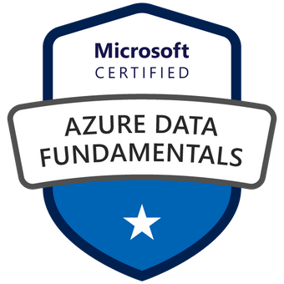
MICROSOFT CERTIFIED AZURE FUNDAMENTALS 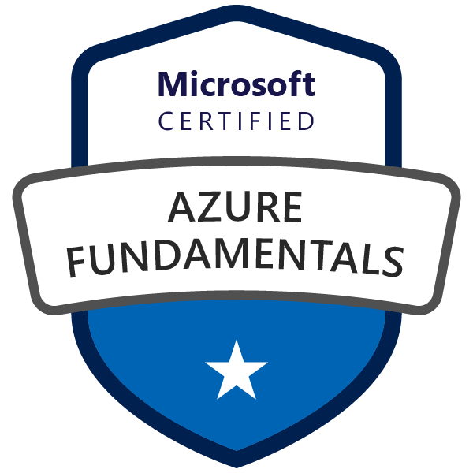
Oracle Cloud Infrastructure Foundations Certified Associated 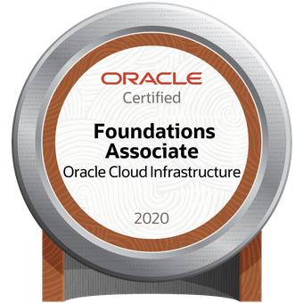
Microsoft Power BI Desktop | Advanced Integration Services | SSIS Design Patterns for Data Warehousing |

Volunteer:
Social Coder – Volunteer Software Developer 2017 – Present
Education Inc. – Volunteer Software Developer 2014
World Vision / Children’s International – Volunteer / Donor 2012 – 2013

